

**Incident Report:**

**Khamis Abbakar, Governor of West Darfur, abducted and killed in El Geneina**

***WARNING: This report contains descriptions of graphic violence.***

**Summary:** CIR has verified information related to the abduction and killing of Khamis Abbakar, Governor of West Darfur, in El Geneina.

**Detail:**

On the evening of 14 June 2023, a video was circulated by an [account on Twitter](https://twitter.com/HkZuk) showing the abduction of Khamis Abbakar, the Governor of West Darfur. Earlier in the day, the Governor had given a TV interview which can be viewed on the channel, [AlHadath’](https://twitter.com/AlHadath/status/1669011820814663682)s Twitter account, condemning the violence in Darfur. During the interview he also requested foreign intervention and aid.

The footage shows the governor being escorted from a vehicle to a small building with the label of “commander's office” above the door. Analysing elements in the footage including a sign above a door that reads “Commander”, a flag holder and its colour scheme that is commonly used at military sites in the country, CIR analysts have concluded that the area shown in the video was a military compound located in El Geneina, just north of the university area. Its identity as a military site is indicated by the colour scheme and the presence of a flag holder on the exterior of the building.

A few hours later more footage (WARNING:HIGHLY GRAPHIC) was released of the Governor by [Twitter](https://twitter.com/sudaniaat/status/1669315896249024514?s=20) account (assessed as opposing RSF) showing he had been killed and his body was being abused. The act has already provoked backlash (discussed in this article published by [BBC News)](https://www.bbc.co.uk/news/world-africa-65914569) and many institutions and governments have come out to condemn the wider violence occurring in Darfur (exampled in a statement released by the [US Department of State)](https://www.state.gov/condemning-atrocities-in-darfur/).

Although the RSF have publicly [denied](https://twitter.com/RSFSudan/status/1669325565118107650) killing the Governor via a statement posted on their official Twitter account, [@RSFSudan,](https://twitter.com/RSFSudan/status/1669325565118107650) footage posted on Twitter by journalist working for [Sudan War Monito](https://twitter.com/4no0s7/status/1669109265150234635)r shows the commander of the RSF in West Darfur, General

Abdul Rahman Juma, seen escorting the governor into the building labelled “commander's office”. CIR was able to verify this additional footage to the same military compound in El Geneina. This is the last known footage of the governor still alive.

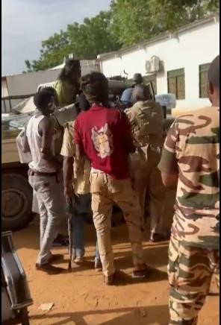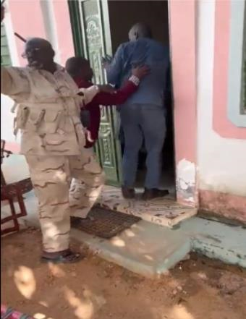

*Figure 1. The Governor being escorted (left). General Abdul Rahman Juma, RSF (right)*

# [13.4350000, 22.4213889]

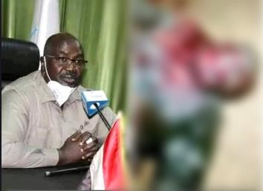

*Figure 2. Stills of Khamis Abbakar before and after assassination. [Locations Unknown]*

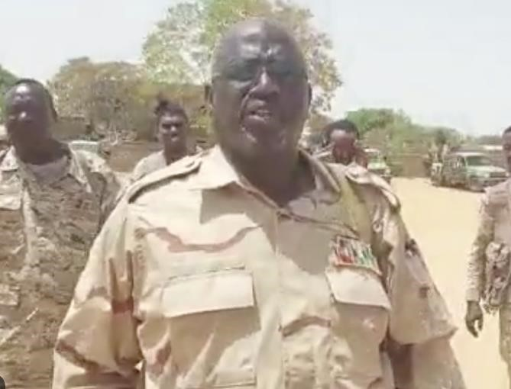

# Figure 3. General Abdul Rahman Juma. [Location Unkown]

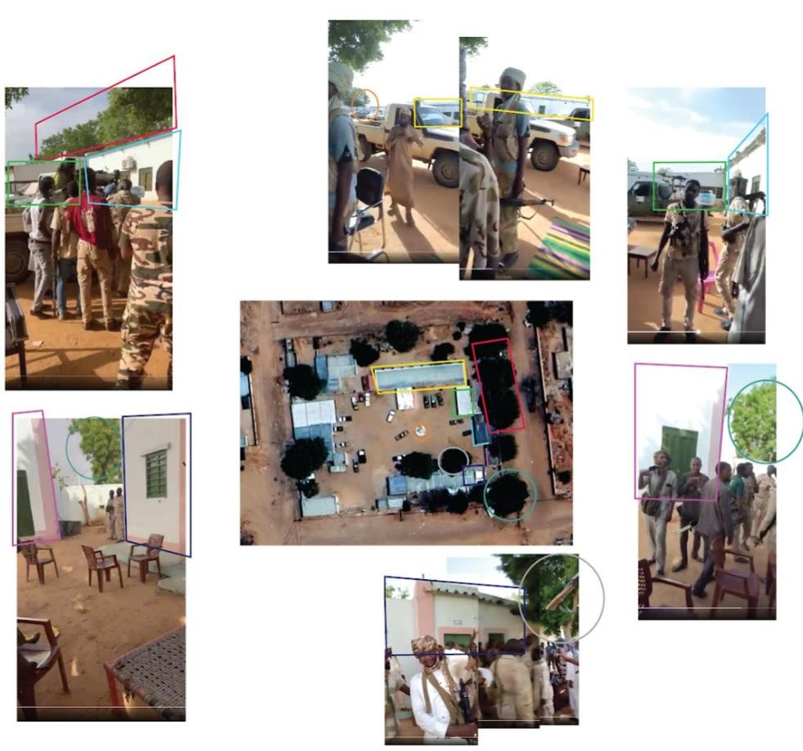

*Figure 4. Geolocation of abduction videos posted by Sudan War Monitor and @HkZuk. The geolocation proof is a collaboration of both pieces of footage. [13.4350000, 22.4213889]*

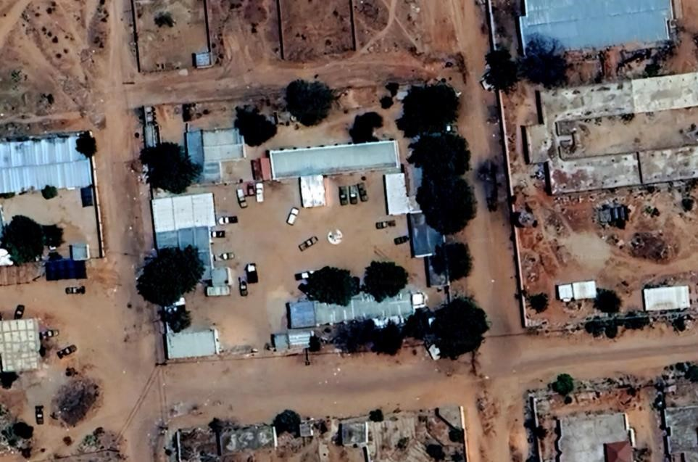

*Figure 5. Satellite image of the military compound. [13.4350000, 22.4213889]*

Several elements of the abduction video were used to identify its location. Firstly, it was widely shared that the governor was taken to El Geneina (reported by [BBC News)](https://www.bbc.co.uk/news/world-africa-65914569), so this provided a good starting point. When looking for the compound itself; there are 3 right angles present from the shape of the structure (yellow, green, and blue squares) along with the ‘commander's office’ adjacent to these buildings (purple square). A treeline can be seen behind the three right-angled buildings (red square) and a large tree behind a small wall situated between the ‘commander's office’ and the other structure (blue circle). The compound is in the western area of El Geneina, just over 600m north-east of the university.